**CP Club 365Days Challenge**

**Programming language – PYTHON**

**Problem Statement**

[https://practice.geeksforgeeks.org/problems/isomorphic-strings-1587115620/1?page=1&difficulty[]=0&category[]=Strings&sortBy=submissions](https://practice.geeksforgeeks.org/problems/isomorphic-strings-1587115620/1?page=1&difficulty%5b%5d=0&category%5b%5d=Strings&sortBy=submissions)

**Your Code**:

# 0x60Day of 0x365Days challenge

# VEDANT BHARAD

# 16-12-2022

#{

# Driver Code Starts

#Initial Template for Python 3

import atexit

import io

import sys

from collections import defaultdict

_INPUT_LINES = sys.stdin.read().splitlines()

input = iter(_INPUT_LINES).__next__

_OUTPUT_BUFFER = io.StringIO()

sys.stdout = _OUTPUT_BUFFER

@atexit.register

def write():

    sys.__stdout__.write(_OUTPUT_BUFFER.getvalue())

if __name__=='__main__':

    t = int(input())

    for i in range(t):

        s=str(input())

        p=str(input())

        ob = Solution()

        if(ob.areIsomorphic(s,p)):

            print(1)

        else:

            print(0)

# } Driver Code Ends

**Output (Screen Shot)**:

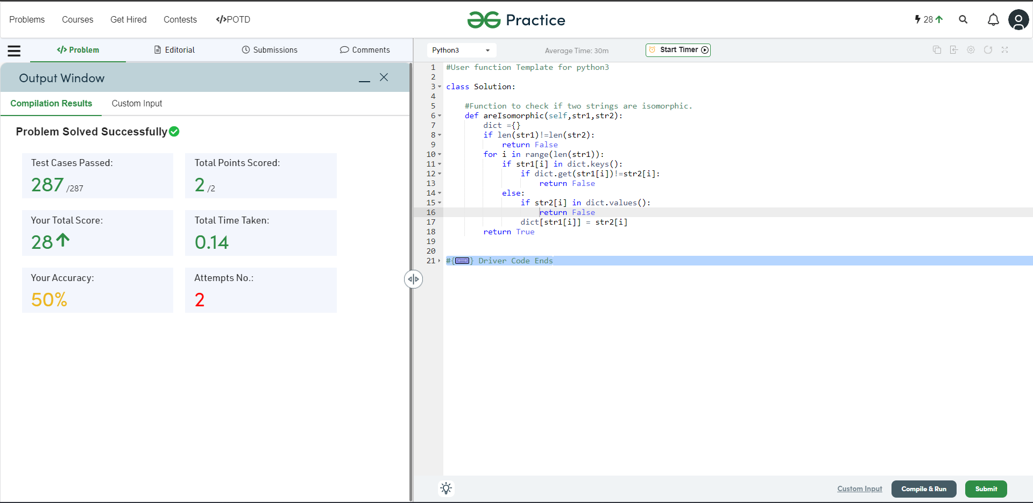

**Understanding about problem:**

1. In this task there is two input and both are string and I need to return 0 or 1.
2. if two strings are isomorphic then return 1 else 0.

Note: If you can't understand the problem, feel free to contact us and we'll help you. Please don't copy and paste from anywhere.

ALL THE BEST

Team CP Club